
DEPARTMENT OF COMPUTER SCIENCE
━━━━━━━━━━━━━━━━━━━━━━━━━━━━━━━━━━━━━
SignSense AI
Traffic Sign Recognition Using Deep Learning
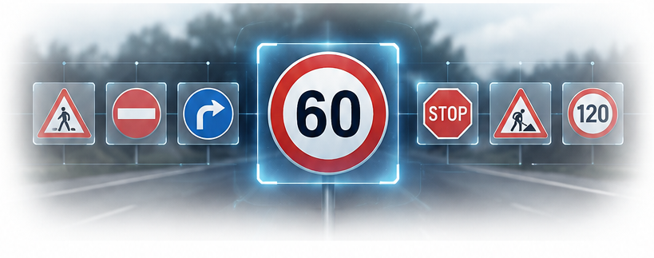
SUBMITTED BY
Farhan Habib
Roll No.: SU92-BSCSM-F23-587
SUBMITTED TO
Mr. Munir Ahmed
COURSE: Deep Learning
SECTION: 7B
SUBMISSION DATE: 31 October 2026

Abstract
SignSense AI is a deep learning system that recognizes traffic signs from an uploaded or camera-captured image. A convolutional neural network (CNN) was trained on the German Traffic Sign Recognition Benchmark (GTSRB), which contains 43 sign classes. The final model reaches 98.44% accuracy on the official GTSRB test set (macro precision 98.10%, macro recall 97.75%, macro F1-score 97.82%). Because a standard classifier always picks one of its known classes, even for images it has never seen, the model was extended with a 44th output class, Not a traffic sign, so unrelated images and signs outside the training set can be reported as not recognized. The model is deployed as a Streamlit web application that shows the predicted sign, a confidence score, the top predictions, a Grad-CAM heatmap of where the model is looking, and batch analysis of many images at once.

1. Introduction

1.1 Problem statement
Traffic signs communicate rules and hazards to drivers. Automatic recognition of signs is a core component of driver-assistance systems and autonomous vehicles. The task is difficult because real images vary in lighting, size, blur, viewing angle and background, and because many sign classes look alike (for example, the different speed limits).
The goal of this project is to build a classifier that, given an image of a traffic sign, outputs the name of the sign and how confident the model is, and to make this available through a simple web interface.

1.2 Objectives
- Train a CNN that classifies the 43 GTSRB sign classes with high accuracy.
- Evaluate the model with accuracy, precision, recall, F1-score and a confusion matrix on data the model has not seen.
- Make the model reject images that are not one of the 43 known signs instead of forcing a wrong match.
- Deploy the model as a public web application and publish the code, model weights and documentation on GitHub.

1.3 Tools and technologies
Area | Tools
Language | Python
Deep learning | TensorFlow 2.21 / Keras
Data and evaluation | NumPy, Pandas, scikit-learn, Pillow, Matplotlib, Seaborn
Training environment | Google Colab (NVIDIA T4 GPU)
Web application | Streamlit (deployed on Streamlit Community Cloud)
Version control | Git and GitHub

2. Dataset

2.1 GTSRB
The project uses the German Traffic Sign Recognition Benchmark (GTSRB) (Stallkamp et al., 2012), a secondary dataset downloaded from Kaggle. It contains photographs of German road signs taken in real driving conditions.
Property | Value
Number of classes | 43
Training images | 39,209
Official test images | 12,630
Image size | Variable (roughly 15x15 to 250x250 pixels)
Color | RGB
The 43 classes include speed limits (20 to 120 km/h), prohibitory signs (no passing, no entry), warning signs (curves, road work, pedestrians), priority signs (stop, yield, priority road) and mandatory signs (turn right, keep left, roundabout).
Dataset link: https://www.kaggle.com/datasets/meowmeowmeowmeowmeow/gtsrb-german-traffic-sign
The dataset is not stored in the GitHub repository because of its size (about 612 MB). The repository links to the Kaggle page instead.

2.2 Characteristics and challenges
- The images are small, often blurry, and taken under varying light, which makes classification harder than on clean images.
- Classes are imbalanced: some classes have several times more images than others.
- Training images come in groups of about 30 consecutive photos of the same physical sign. Near-identical images are therefore common, which affects how validation results should be interpreted (see Section 5.3).

2.3 Additional data for the “Not a traffic sign” class
To teach the model to reject unknown inputs, three kinds of extra training images were added (see Section 3.4):
- 2,000 everyday photographs from CIFAR-100 (Krizhevsky, 2009).
- 4,000 generated sign-like images that are not GTSRB signs (other shapes, colors and pictograms).
- 8,000 “clean graphic” copies of real GTSRB signs, labelled with their correct classes, so that the model does not learn to treat clean, sharp images as unknown.

3. Methodology

3.1 Preprocessing
- Each image is read with Pillow, converted to RGB and resized to 32x32 pixels. A fixed size is required by the CNN, and a small size keeps training fast.
- Pixel values are scaled to the range 0 to 1 by a Rescaling layer that is part of the model. Doing this inside the model guarantees that the web application applies exactly the same normalization as training.
- The training data is split into training and validation sets using a stratified split (stratify=y) so that every class keeps the same proportion in both sets.

3.2 Data augmentation
Augmentation layers are part of the model and are active only during training:
- Random contrast (factor 0.2)
- Random rotation (about ±5% of a full turn)
- Random zoom (10%)
- Random translation (10% in both directions)
Horizontal flipping was deliberately not used, because flipping would turn “Turn left ahead” into “Turn right ahead” and change the class.

3.3 Model architecture
The model is a CNN built with the Keras Sequential API.
Block | Layers
Input | 32x32x3 image, contrast augmentation, rescaling to 0-1, rotation / zoom / translation augmentation
Block 1 | Conv2D(32, 3x3, ReLU), BatchNormalization, Conv2D(32, 3x3, ReLU), MaxPooling, Dropout(0.25)
Block 2 | Conv2D(64, 3x3, ReLU), BatchNormalization, Conv2D(64, 3x3, ReLU), MaxPooling, Dropout(0.25)
Block 3 | Conv2D(128, 3x3, ReLU), BatchNormalization, MaxPooling, Dropout(0.25)
Classifier | Flatten, Dense(256, ReLU), Dropout(0.5), Dense(44, softmax)
Why these components were chosen:
- Convolution and max pooling extract visual features such as edges, shapes and symbols, and reduce the spatial size step by step.
- Batch normalization (Ioffe and Szegedy, 2015) stabilizes and speeds up training.
- Dropout (Srivastava et al., 2014) reduces overfitting.
- Softmax gives a probability for each class. The largest probability is the prediction and is shown to the user as the confidence score.

3.4 Handling images that are not one of the 43 signs
A softmax classifier must always choose one of its known classes. If an unknown image is shown, it is matched to the most similar known class, often with high confidence. This is a known limitation of closed-set classification.
To address it, the model has 44 outputs: the 43 GTSRB signs and Not a traffic sign. The extra class is trained on:
- Everyday photos (CIFAR-100), which teach the model to reject unrelated content.
- Generated sign-like images with different shapes (triangles, circles, squares, hexagons), colors and random pictograms, letters and numbers. These act as “hard negatives”: they look like signs but are not GTSRB signs. Care was taken not to generate images that imitate real classes, such as inverted red triangles (Yield) or red circles with a bar (No entry).
- Clean-graphic copies of real signs, labelled with their true classes, so that clean or high-resolution images are not mistaken for unknown ones.
The final training pool contains 53,209 images: 39,209 original GTSRB images, 8,000 clean-graphic copies and 6,000 negative images.

3.5 Training configuration
Setting | Value
Optimizer | Adam
Loss | Sparse categorical cross-entropy
Batch size | 64
Maximum epochs | 30
Early stopping | Monitor validation accuracy, patience 5, restore best weights
Learning-rate schedule | ReduceLROnPlateau on validation loss (factor 0.5, patience 2)
Validation split | 15%, stratified, random seed 42
Hardware | Google Colab, NVIDIA T4 GPU
Early stopping ends training when validation accuracy stops improving and restores the best weights, which prevents overfitting. The learning rate is halved when validation loss stalls.
Figure 1: Training and Validation Accuracy and Loss Curves.
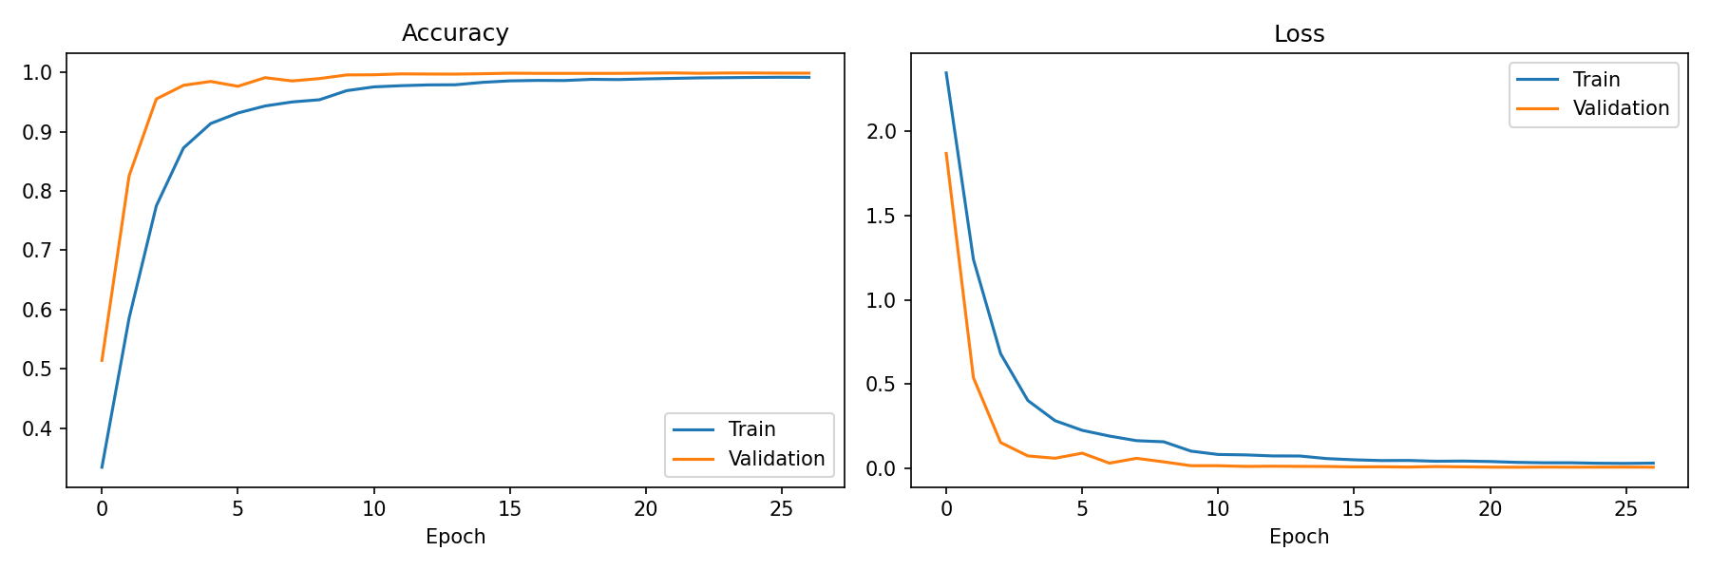

4. Web Application
The trained model is served through a Streamlit application with a dark, modern interface.
Main features
- Recognize: upload an image or take a photo with the camera. The app shows the predicted sign, a confidence gauge, the sign category (speed limit, prohibitory, warning, priority, mandatory, end of restriction), the top 5 predictions and a probability chart.
- Not recognized: if the model assigns the image to “Not a traffic sign”, or the confidence is below a user-set threshold, the app reports that the sign was not recognized instead of showing a sign name.
- Where the model looks: a Grad-CAM heatmap (Selvaraju et al., 2017) highlights the image regions that influenced the prediction, which helps explain the result.
- What the model sees: the 32x32 version of the image that is actually given to the network.
- Batch analysis: upload up to 50 images and get a results table with a CSV download.
- Sign library: searchable list of all 43 classes grouped by category.
- Settings: optional contrast enhancement, center-crop to square, and a confidence threshold.
- About the project: dataset details, model architecture, performance metrics, and links to the report, presentation, video and repository.
- Downloads: each result can be saved as a JSON file.
Deployment. The code, trained model (signsense_model.keras) and class names are stored in a public GitHub repository. The app is deployed on Streamlit Community Cloud with Python 3.11 and tensorflow-cpu==2.21.0. The repository also contains an evaluate.py script that loads the saved model and evaluates it on the official GTSRB test set.

5. Results

5.1 Final model
All metrics below were measured on the official GTSRB test set (12,630 images), which was never used during training, except where stated.
Metric | Value
Test accuracy (43 real signs) | 98.44%
Macro precision | 98.10%
Macro recall | 97.75%
Macro F1-score | 97.82%
Real signs wrongly rejected as “Not a traffic sign” | 0.35%
Real signs in clean-graphic style recognized correctly | 98.47%
Unseen everyday photos (CIFAR-100 test images) rejected | 98.80%
Unseen generated unknown signs rejected | 100% (optimistic, see below)
The rejection rate on generated unknown signs is measured with the same generator that produced the training negatives, so it overestimates real-world performance. It is reported for completeness only.
Figure 2: Confusion Matrix on the Official GTSRB Test Set.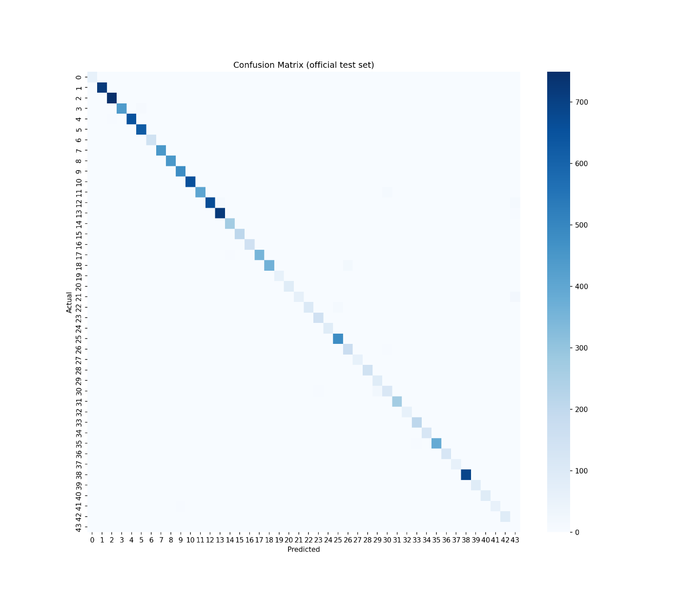

5.2 Comparison of the two model versions
 | Version 1 | Version 2 (final)
Output classes | 43 | 44 (43 signs + Not a traffic sign)
Unknown images | Forced into the closest sign | Reported as not recognized
Official test accuracy | 97.73% | 98.44%
Version 2 improved test accuracy by about 0.7 percentage points. A likely reason is the additional contrast augmentation and the clean-graphic copies, which add variety to the training data. This explanation was not tested separately.

5.3 Validation accuracy versus test accuracy
With version 1, validation accuracy was 99.94% while test accuracy was 97.73%. The difference is explained by the structure of GTSRB: because training images come in groups of near-identical photos of the same physical sign, a random train/validation split places very similar images in both sets. The validation score is therefore optimistic. The official test set contains different physical signs, so the test accuracy is the realistic measure and is used as the main result throughout this report.

5.4 Manual testing in the web application
The deployed application was tested manually with real sign photos, a clean graphic image of a stop sign, a German sign that is not part of GTSRB (a steep-descent warning sign) and unrelated photos. The application gave the expected outcome in these tests. These are informal checks and not a substitute for the quantitative results above.

6. Challenges and Iterations
- Overconfident wrong predictions on unknown signs. The first model matched a steep-descent warning sign, which is not in GTSRB, to the class “Bicycles crossing” with about 99% confidence. This shows that a high softmax confidence does not guarantee a correct match for inputs outside the training classes.
- Feature-distance detector. As a first fix, a Mahalanobis-distance detector was built on the 256-dimensional features of the network, with a threshold taken from the test set. It flagged the steep-descent sign (score 1.21 against a limit of 1.0) but also flagged a clean, high-quality stop sign graphic (score 2.86), which is a known GTSRB class. The detector measured image style as much as sign identity, so it could not satisfy both requirements.
- Final solution. The model itself was retrained with a 44th class and with hard-negative examples (Section 3.4). This lets the network learn what an unknown sign looks like. The clean-graphic copies of real signs were added specifically so that clean images are not treated as unknown. After retraining, only 0.35% of real test signs were rejected and 98.47% of clean-graphic signs were still recognized.
- Library compatibility. Newer Streamlit versions deprecate some layout arguments, so the application uses a small helper that works on both old and new versions. TensorFlow was pinned to the training version (2.21.0) to avoid model-loading errors.

7. Limitations
- The model works on 32x32 images. Fine details are lost, and photos with cluttered backgrounds or several signs can lower confidence.
- The model knows 43 German signs only. Signs from other countries or sign types outside GTSRB are rejected only when they resemble the generated unknown examples used in training, so an occasional unknown sign can still be matched to a known class.
- The “Not a traffic sign” class is trained with synthetic negatives. It is not a guarantee against every possible unknown input.
- The network classifies a single, centered sign. It does not detect and locate signs in a full street scene.
- Test results come from GTSRB images. Performance on other cameras, countries and weather conditions was not measured.

8. Future Work
- Add a detection stage (for example YOLO) so signs can be found in full road images before classification.
- Train on additional datasets from other countries to broaden the set of recognized signs and to provide real examples of unknown signs.
- Use higher input resolution or a pretrained backbone (transfer learning, for example MobileNet) to improve accuracy on difficult classes.
- Evaluate robustness under fog, rain, night and motion blur, and add matching augmentation.
- Export the model to a lightweight format for mobile or embedded use.

9. Conclusion
SignSense AI shows that a compact CNN trained on GTSRB can recognize 43 traffic sign classes with 98.44% accuracy on an unseen test set. Extending the network with a “Not a traffic sign” class addresses the closed-set weakness of ordinary classifiers: unrelated images and many unknown signs are reported as not recognized instead of being forced into a wrong class, while only 0.35% of real signs are rejected by mistake. The project covers the complete workflow: data preparation, model design, training, evaluation, explainability with Grad-CAM, deployment as a web application, and publication of code and weights on GitHub.

10. Project Links
Resource | Link
Live web application | https://signsense-ai-gbmrkxzxzmrgkewc7wgdfa.streamlit.app/
GitHub repository (code and model weights) | https://github.com/fh545599-byte/SignSense-AI
Dataset (Kaggle) | https://www.kaggle.com/datasets/meowmeowmeowmeowmeow/gtsrb-german-traffic-sign
Presentation | To be added
YouTube video | To be added

References
- Stallkamp, J., Schlipsing, M., Salmen, J., and Igel, C. (2012). Man vs. computer: Benchmarking machine learning algorithms for traffic sign recognition. Neural Networks, 32, 323-332.
- Ioffe, S. and Szegedy, C. (2015). Batch Normalization: Accelerating Deep Network Training by Reducing Internal Covariate Shift. ICML.
- Srivastava, N., Hinton, G., Krizhevsky, A., Sutskever, I., and Salakhutdinov, R. (2014). Dropout: A Simple Way to Prevent Neural Networks from Overfitting. Journal of Machine Learning Research, 15, 1929-1958.
- Kingma, D. P. and Ba, J. (2015). Adam: A Method for Stochastic Optimization. ICLR.
- Selvaraju, R. R. et al. (2017). Grad-CAM: Visual Explanations from Deep Networks via Gradient-based Localization. ICCV.
- Krizhevsky, A. (2009). Learning Multiple Layers of Features from Tiny Images. Technical report, University of Toronto.
- Abadi, M. et al. TensorFlow: Large-scale machine learning on heterogeneous systems. https://www.tensorflow.org

